ТАНИЯРОВА Айсулу Бахитовна,
Зоя Космодемьянская атындағы №23 мектеп-лицейінің ағылшын тілі пәні мұғалімі.
Шымкент қаласы

TRANSPORT: NOUNS

Learning objectives(s) that this lesson is contributing to |  | 8.1.8.1 develop intercultural awareness through reading and discussion;  8.3.7.1 use appropriate subject-specific vocabulary and syntax to talk about a range of general topics, and some curricular topics;  8.6.7.1 use a variety of simple perfect forms to express recent, indefinite and unfinished past on a range of familiar general and curricular topics.
Lesson objectives to: |  | - do a questionnaire about famous explorers and answer the questions;  - speak fluently about past event using the past perfect and discuss means of transport.
The course of the lesson.
Stages/Time | Teacher's actions |  | Student`s actions | Assessment criteria | Resources
Greeting.  Organization moment.  5 min. | Organization moment  1.Greeting.  Ask about the weather.  The teacher sets the lesson objectives, letting students know what to anticipate from the lesson.  Warm-up  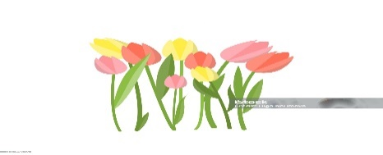  Students wish each other by holding a flower.  Teacher asks students look at the Active board and spins the wheel. Teacher check the home task by method " Picker wheel " method |  | The aim: To develop pupils speaking skills and create friendly atmosphere  Efficiency: By telling the wishes they show their appreciations .  Students of the class are listed.  Students' attention is drawn to the lesson.  Students answer “Yes” or “No”  Students remind the previous lessons. | At the organization moment teacher tries to award active pupils. «The praise» method is used to evaluate pupils with phrases like:  “Good job!  Well done!”  Formative Assessment  Verbal assessment  2 point  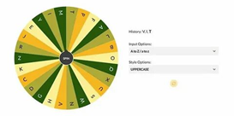 | Bouquet flowers  Active board  https://pickerwheel.com/
5 min. | The teacher asks the students to look at the blackboard and watch a video  - What did you see in the video?  - What about this video?  - How do you think what is our theme?  The teacher sets the lesson objectives, letting students know what to anticipate from the lesson.  Differentiation: Modelling- teacher gives clear description of the task with examples  By task – more motivated learners can do task without support  Less motivated learners will be given prompts to find the correct answer. |  | Students watch the video and answer the questions | Assessment criteria  - watch the video  Descriptor:  - Ss give full answers about means of transport  Self-assessment  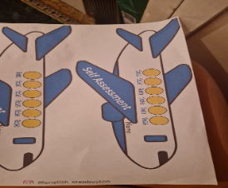 | Active board  https://www.youtube.com/watch?v=cRg-U8IukAA
2 min. | Teacher introduce students with new words  Boat [bəʊt] қайық  Spacecraft [ˈspeɪskrɑːft] Ғарыш кемесі  Submarine [sʌbməˈriːn] Сүңгуір қайық  Tram [træm] Трамвай  Helicopter [ˈhelɪkɒptə] Тікұшақ  Explorers [explorers] Зерттеушілер  Disappeared [dɪsəˈpɪəd] Жоғалып кету  Camel [ˈkæməl] түйе  Plane [pleɪn] Ұшақ  Lorry [ˈlɒrɪ] Жүк көлігі  Horse [hɔːs] Жылқы  Train [treɪn] Пойыз  Airship [ˈeəʃɪp] әуе кемесі |  | Students write the words correctly and work with translation. | Assessment criteria  - Learn vocabulary  -remember the pronunciations  Descriptor:  A learner  -writes new words correctly | Active board  Worksheet  Student’s book
3 min. | Task1. Method “Who is the Quicker”  Individual work.  • Students use their dictionaries to check the meaning of the words in the box and write the words in the correct part of the table.  Land transport Air transport Water transport  Differentiation:  «Verbal support» method is used to help Students use new words. |  | Students look at the photos and try to answer more as they can in 1 minute.  ANSWERS:  Land:  bus, camel, car, bicycle, train, horse, lorry, tram  Water: boat, ship, submarine  Air: plane, helicopter, spacecraft, airship | Assessment criteria  -determine the types of transport  Descriptor:  -A learner  looks at the pictures;  -complete the table;  Teacher’s assessment | Whiteboard  Student’s book  Pictures
Pre -reading  Main part of the lesson  3 min.  Middle of the lesson  10 min. | Pre-reading. Brainstorming. The method “Think and say”  Teacher elicits students’ knowledge about  Teacher shows some pictures of transports travellers  Work in individual. Look at the picture and answer the questions.  - Who is the most famous explorer from our country?  - Do you like to travel? Why/ Why not?  - How do you usually get to school?  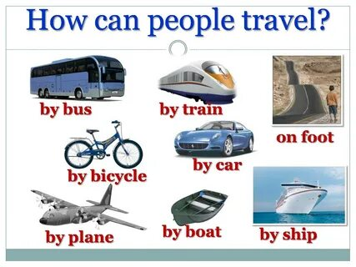  Task 3 Listening. Individual work  • Students do the questionnaire.  • When the students have answered all the questions, play the CD for the students to listen and check their answers.  Task 4 Reading. Matching  Teacher asks students to do the Explorers quiz. Then match the texts 1–5 with photos A–E. Which explorer’s journey do you think was the most difficult? Why?  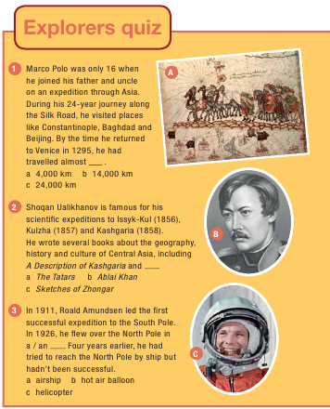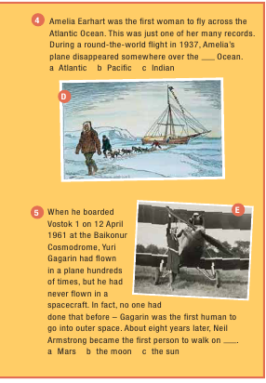 |  | Students look at the photos and try to answer more as they can in 1 minute  Students do the Explorers quiz. Then listen and check your answers.  ANSWERS:  1 c  2 c  3 a  4 b  5 b  Students work in individually do the Explorers quiz. Then match the texts 1–5 with photos A–E. Which explorer’s journey do you think was the most difficult? Why?  Answers:  1 A  2 B  3 D  4 E  5C | Descriptor:  A learner  -use their ideas  Good job!  Assessment criteria:  - Do a  questionnaire about  famous explorers.  Descriptor:  - do the Explorers quiz  - listen and check your answers  Teacher’s assessment.  Assessment criteria:  - Determine the phrases  Descriptor:  - Match the pictures correctly  Teacher’s assessment. | Pictures  English plus p 80  https://youtu.be/clxtx3oZ4fI?si=tRO0EoZCdZKZDX4d  Student’s book p80
2 min. | Relax time  Listening the sound of transport |  | Students should find what transport is. |  | video
5 min.  5 min. | Past perfect  Video Rules  Teacher explain the rule to the students:  a) We form the past perfect with had and a past participle.  b) We form negative sentences with not or  never.  c) We use the past perfect to talk about  an action that happened before  another action in the past.​  Task 4 Writing Group work  Study the quiz again and find the sentence in past perfect form.  Task 5. The method True or False  1 During his 24- year journey with his father the Skill Road, he visited places like Constantinople, Baghdad and Beijing  2 Shoqan Uakihanov wrote several books about the geography, history and culture of Central Asia.  3In 1926, Roald Amundsen led the first successful expedition to the South Pole.  4 Amelia Earhart was the first woman to fly across the Atlantic Ocean.  5 On 11 April 1961 at the Baikonur Cosmodrome, Yuri Gagarin was the first human to go into space. |  | Students watch the video than to the teacher’s explanation and say their opinion about rule  Answers:  1F  2T  3F  4T  5F | Good job!  Verbal assessment  Assessment criteria:  -Use past perfect  -choose the sentence correctly  Descriptor:  - read the examples  - find an example in the text  Assessment criteria:  -remind the information  -answer the questions  Descriptor:  - choose the correct answer  - give reasons | Whiteboard  PPT  English plus p 79  Exercise 1  https://youtu.be/vhZr6nQeSJk?si=kTWeAJRH5m1igBEs 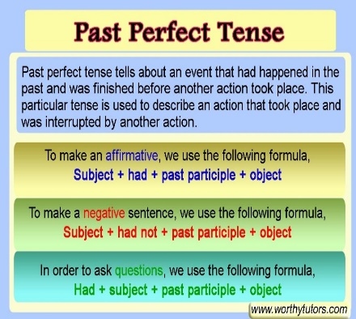
The end of the lesson  3 min. | Teacher gives a homework and comment the work of Sts.  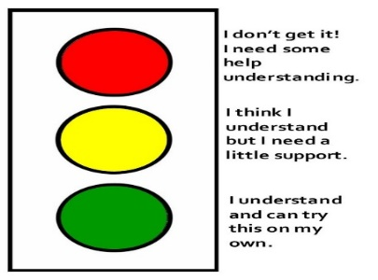  Home Assignment: p81s.b ex5 and speaking |  | Pupils write their homework for the next lesson.  Pupils. give a mark to themselves for working at the lesson.  Students think critically, exploring, developing, evaluating and making choices about their own and others’ ideas. | Pupils evaluate themselves using evaluation lists.  Reflection.  Students use their stickers to show their knowledge according to the lesson. | Stickers

